产 品 承 认 书
Specification for Approval

供应商 : 深圳市欣华天科技有限公司

芯片型号 : RTL8832CU

产品品名 : USB无线网卡

产品型号 : AX3008

日 期 : 2023年04月08日

深圳市欣华天科技有限公司
拟制  PREPARED BY | 审核  CHECKED BY | 批准  APPROVED BY

一.产品
1.品名Name of product: USB无线网卡

2.型号/Model： AX3008

二.材料:
1.主材/Main Material: 玻铝板
2.辅料/Auxiliary Material: ABS料 / USB铁头
3.配件/Accessories: 外置天线
4.其它/Other

三.规格结构:
1.原理图:
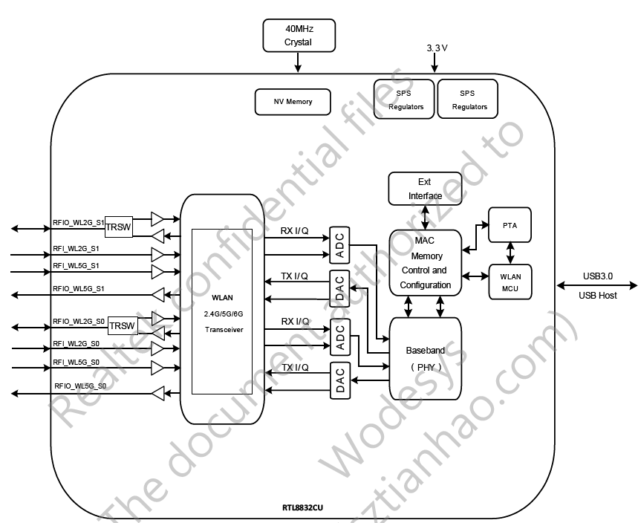

2.内部结构/ Interior Of the Structure:
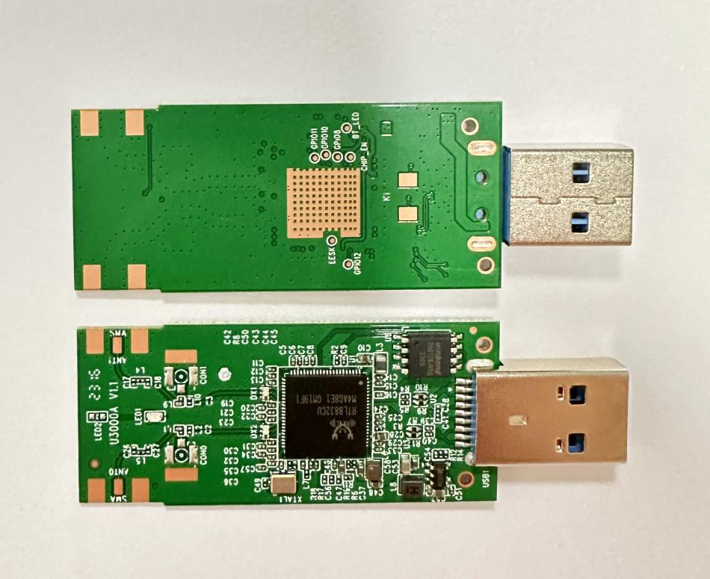

3.外观结构/The Appearance Of the Structure
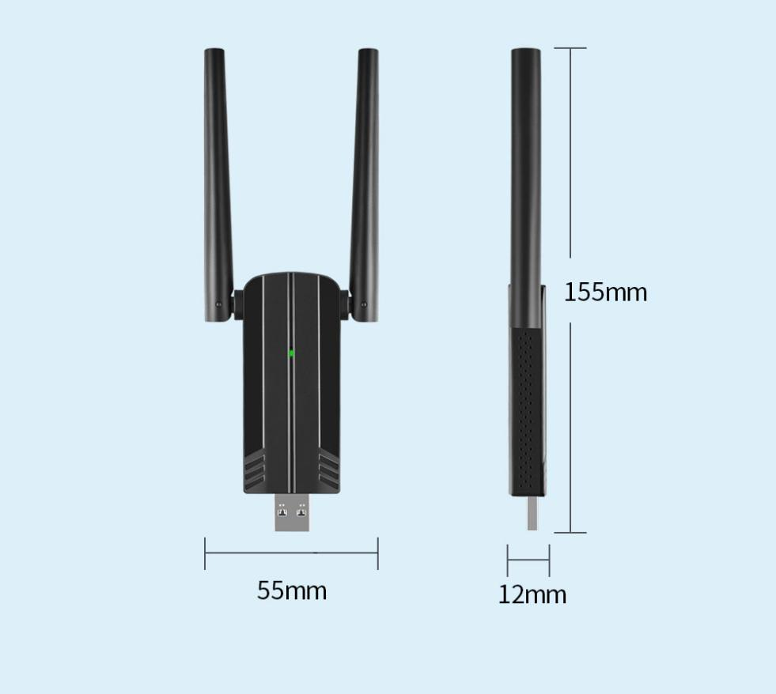

四.常规检测:
1.性能测试/Perfrmance Test:
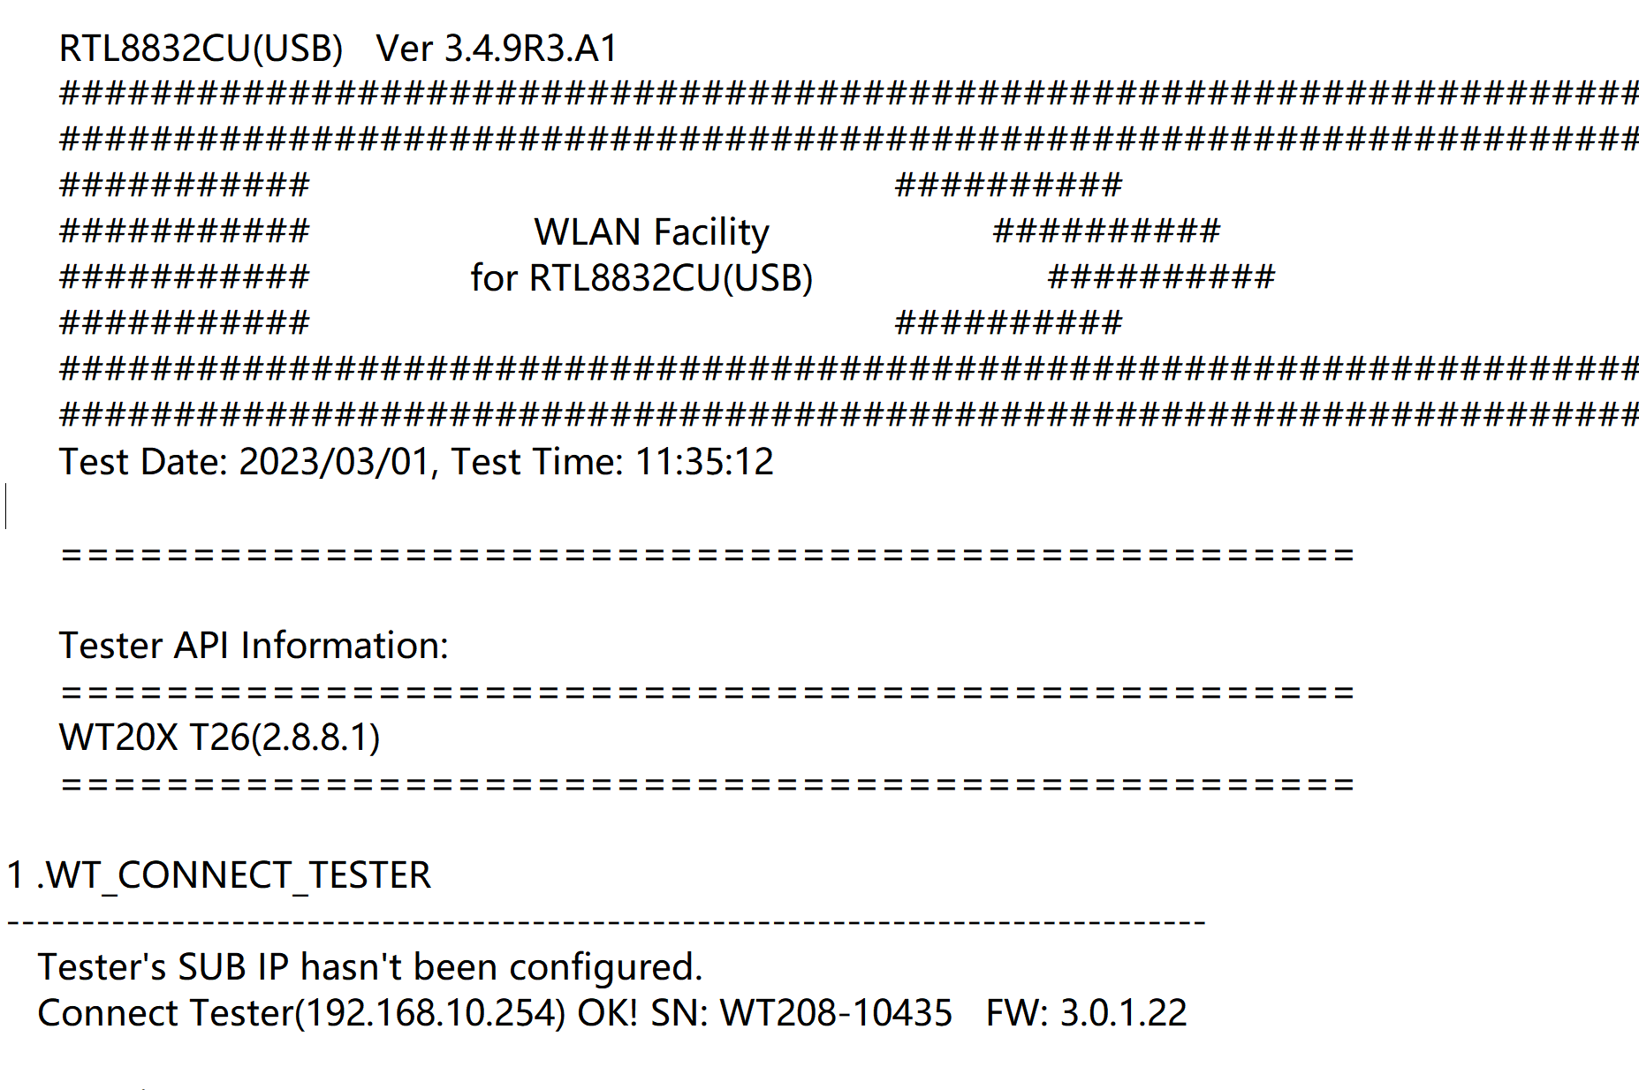
2.吞吐测试/Function test:
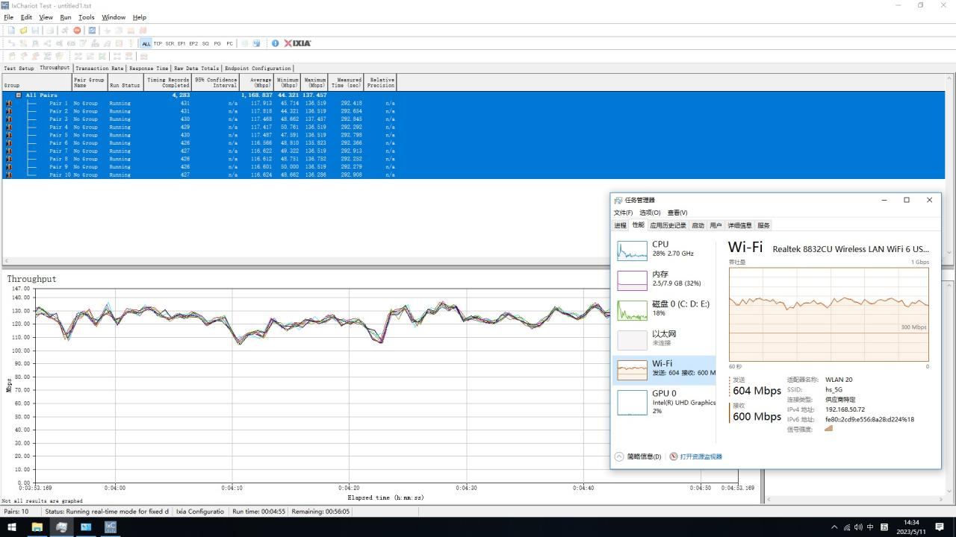

2.功能测试/Function test:

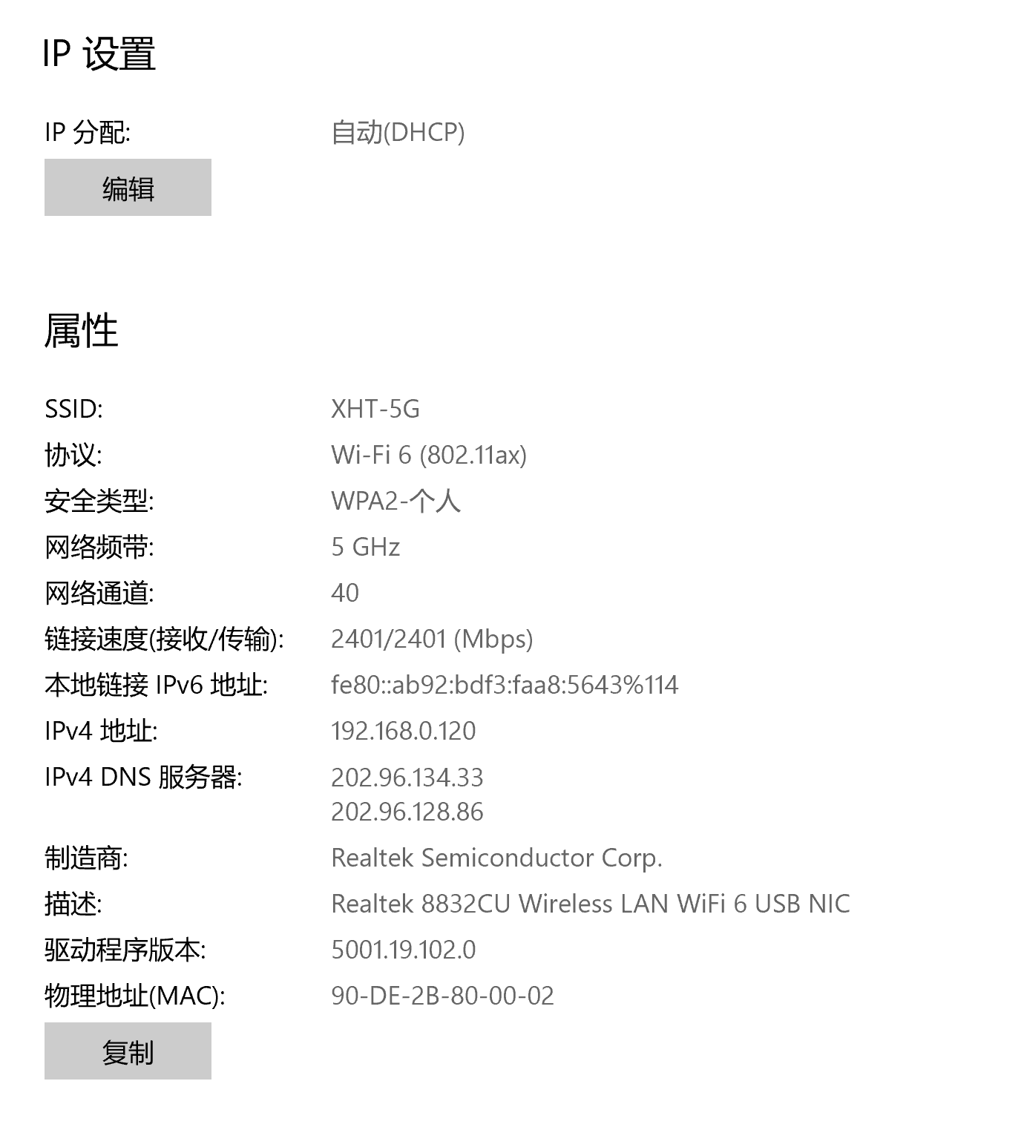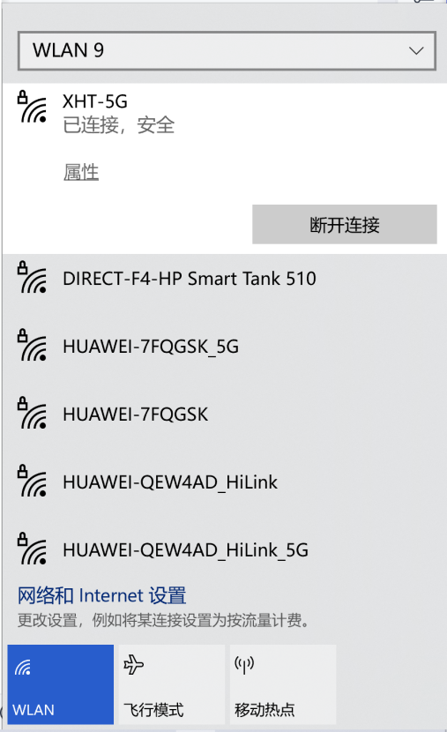

五. 产品规格/:Product specifications:

HARDWARE FEATURES
Interface | USB 3.0
Chipset | Realtek 8832CU
Antenna Type | 5dBi Antenna*2

WIRELESS FEATURES
Wireless Standards | IEEE 802.11ax，IEEE 802.11ac, IEEE 802.11a,  IEEE 802.11n, IEEE 802.11g, IEEE 802.11b
Frequency | 2400~2483MHz/5150~5850MHz/5925~7125MHz
Signal Rate | 2.4GHz: Up to 574Mbps  5GHz: Up to 2401Mbps  6GHz: Up to 2401Mbps
Transmit Power | <20dBm (EIRP)
Wireless Modes | Ad-Hoc / Infrastructure mode
Wireless Security | 64/128 bits WEP, WPA/WPA2, WPA-PSK/WPA2-PSK (TKIP/AES) /WPA3
Modulation Technology | DSSS / DBPSK / DQPSK / CCK / OFDM / OFDMA /  BPSK / QPSK / 16-QAM / 64-QAM / 256-QAM / 1024-QAMA

System Requirements | Windows 10/Windows 11
Temperature Range | Operating: -20ºC to 70ºC, Storage: -40ºC to 90ºC
Humidity | Operating: 5% to 95% (non-condensing)  Storage: Max. 90% (non-condensing)

