AXE5400 Wi-Fi 6E Tri-Band USB AXE5400 WiFi 6E Tri-Band USB Adapter AX3010
5.4 Bluetooth USB Adapter 150M

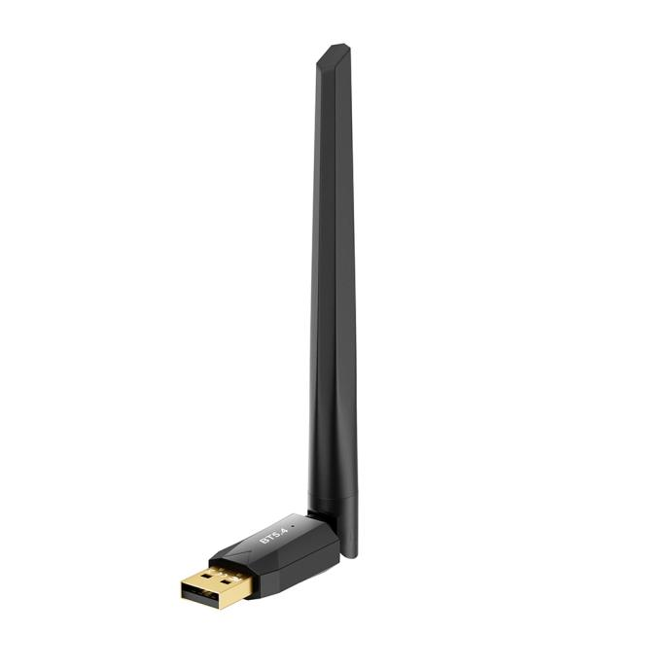

Level Up Your PC

With BT5.4
Adapter

Bluetooth USB Adapter
BT5.4

(BR+EDR+BLE)
BR09


Bluetooth
BT5.4


3M/s
HighSpeed



BR+BLE
+EDR


Long Rang
150M

External
Antenna
Free
Driver

Features

Bluetooth 5.4
Lasteset Bluetooth 5.4(BR+BLE+EDR) For PC Higher Stability Faster Speed More Portable .
Compatible with Bluetooth 2.1/3.0/4.0/5.0/5.1/5.3

High-Fidelity Audio
USB Bluetooth Adapter is equipped with the latest 2024 Bluetooth 5.4 technology, It supports Dual mode (BR/EDR+ Bluetooth Low Energy) to achieve low energy consumption, high speed, and a more stable connection with less sound quality loss.

5dBi Antenna Design
The compact Bluetooth antenna with 5dBi, to get a better signal and keep a stable Bluetooth connection. It can provide more powerful.

Plug & Play
Plug and play for Win11/10/8.1(The latest Bluetooth 5.4 will be shown if you download the driver). Also supports Win7 (driver required for Win7).

Up to 5 Devices Long Rang
You can fully use the USB Bluetooth Adapter to connect multiple devices Transmission up to 150M
simultaneously, Can work with 5 devices at the same time, such as Bluetooth USB antenna high gain antenna can rotate 90°vertically and
Bluetooth speakers, keyboards, headsets, and mice. 180° horizontally for better signal and maintain stable Bluetooth connection

5.4 Bluetooth USB Adapter
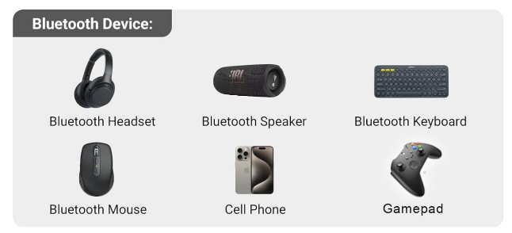

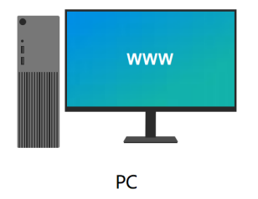

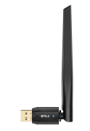
BR-09
dTR

specifications

Version | Bluetooth 5.4
Antenna TypeProfiles | Bluetooth low energy Dual-mode Bluetooth
Frequency Band | 2.402G-2.480G
Sensitivity | -86dBm@.01%BER
RF TX Power | +6dBm(Class П)
Supports Devices: | Bluetooth/Headset/Bluetooth/Keyboard/Bluetooth/Mouse/Bluetooth/Speaker/Mobile phone/Printer/Computers/Game Controller
Support Profile | A2DP/SBC/AAC/HSP/AVRCP/HID etc
data rate | 3M/S
Chipset | RTL8761BUE
distance | 0-150M
System Requirements | Windows 7/8.1/Win10/11
Operating Environment | Operating temperature: 0℃~40℃ (32°F~104°F)  Storage temperature: -40℃~70℃ (-40°F~158°F)  Operating humidity: 10%-90% RH Without condensation  Storage humidity: 5%-90% RH No condensation
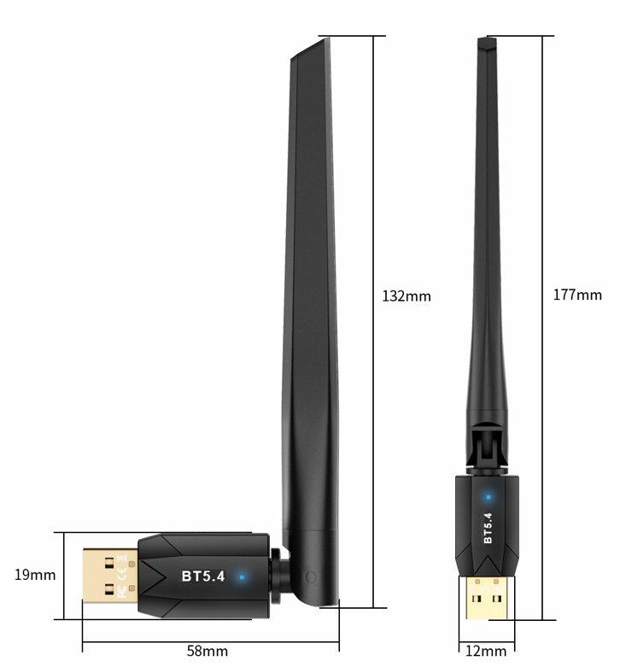

Dimensional Drawing

